OUTREACH

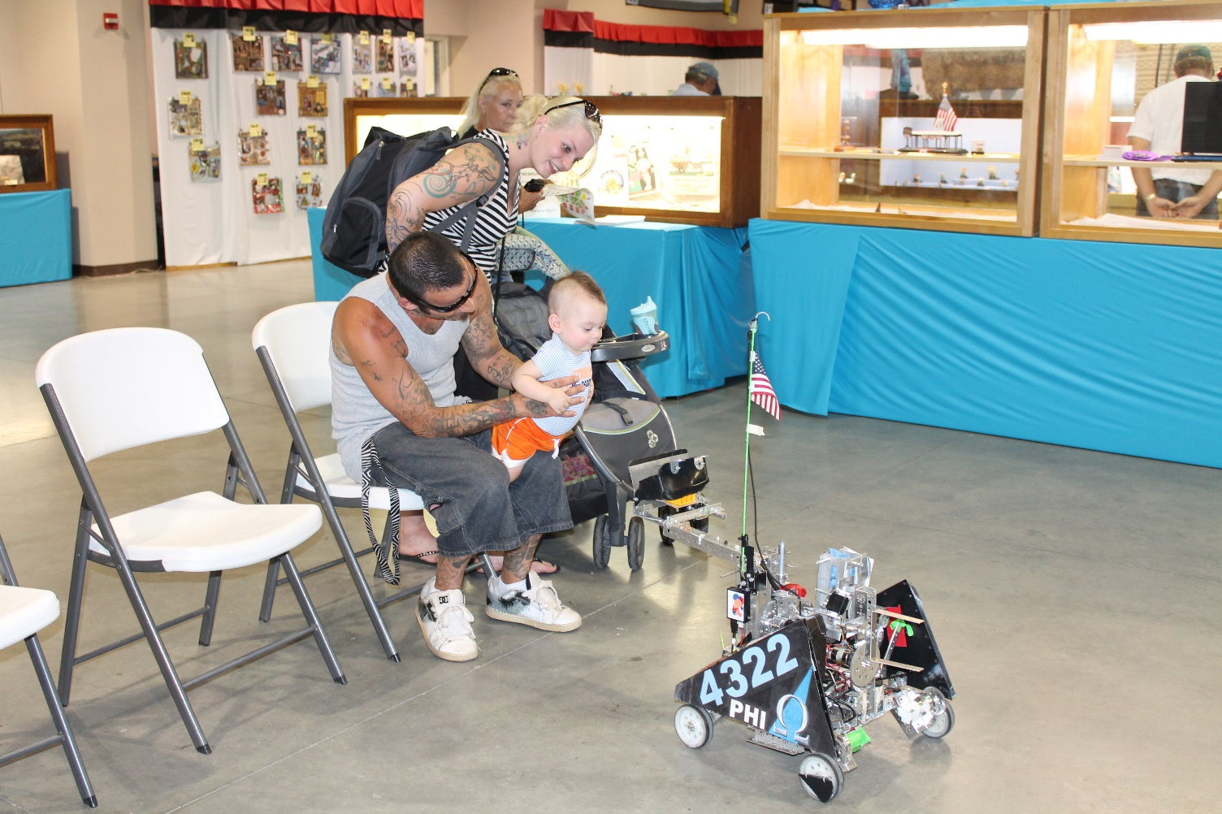

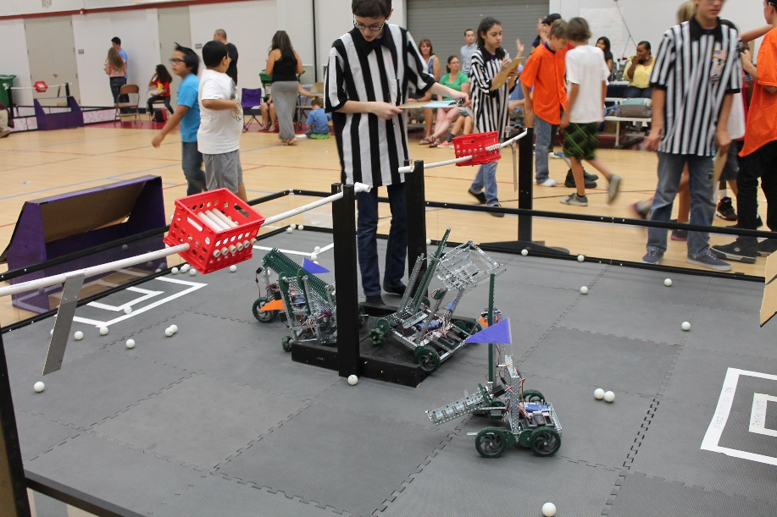
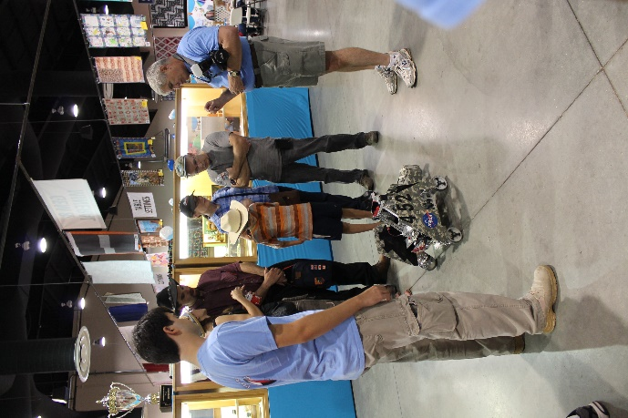
Community Outreach

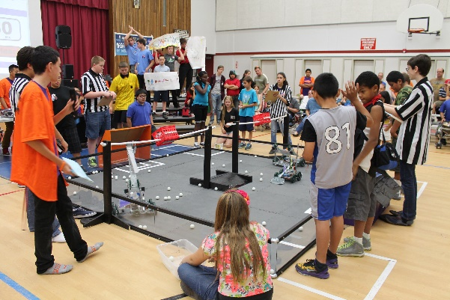
VEX WORKSHOP
Each June, we host our biggest event of the year, a summer workshop in which 40 elementary- and middle-schoolers learn about science, technology, and robotics first-hand by building VEX robots. Ten teams consisting of six students were given a week to build a robot that could accomplish a simple game. High schoolers from local FTC and FRC robotics teams mentored them from June 23rd to the 28th.
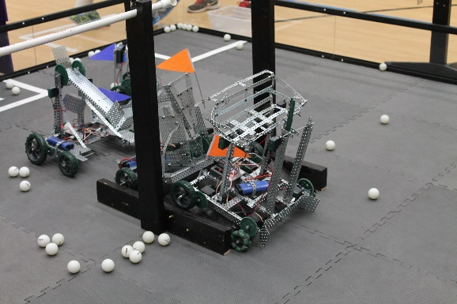
At the end of each FTC-style match, both of the two-robot alliances earned points for racquetballs on the other alliance's side of the field. Toward the end of the week, teams participated in a mock competition to test their skills and show their parents what they learned. The teams then received awards for robot design, team spirit, and logo design.

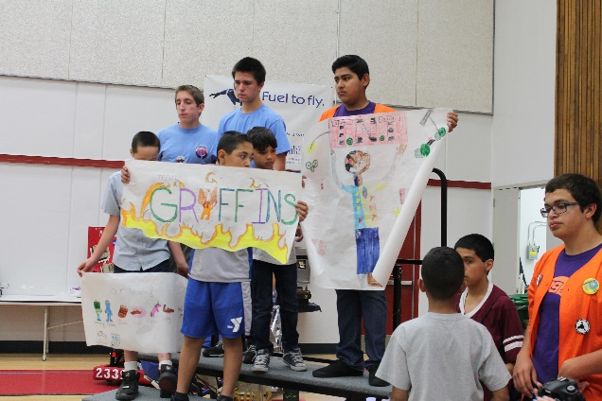
Not only did the middle-schoolers build robots, but they also learn about FIRST core values such as Gracious Professionalism and becoming team players. During the week, presenters from NASA, Northrop Grumman, and Lockheed Martin came to tell the kids about their jobs and how robotics technology is used at their companies. The students especially enjoyed a presentation put on by NASA interns, which told them how science and engineering connects to the kids' daily lives. Teams also got to choose inventive names, create team posters, and design their own team buttons.

The other teams and companies that collaborated with us to make the event possible were Eagle robotics (FRC team #399 and FTC team #72), Bot Squad (Team #5011), Quartz Hill High school, the Robolopes (a local FRC team), Joe Walker Science Jets (several FLL teams), the NASA AERO Institute, Lockheed Martin, and Joe Walker Middle School. NASA provided the ten VEX kits used for the event.

ANTELOPE VALLEY FAIR
This past summer, our team reached out to the coordinators of our local county fair. We proposed an idea to have some of the FIRST teams in our valley get together and run a live display at the then upcoming fair. After several months of working with the other teams and the fair coordinators we had arranged for a few teams to bring their robots to the fair on the weekends and demonstrate them in the community building.
On the first day, we arrived early to work with one of the fair coordinators, Susan Chaisson, to set up our area. We had been allotted a small area inside the community building about 10ft by 20ft surrounded on three sides by chairs. This was a relatively small area to demonstrate a robot but we made it work. Along with the FRC Team 2339 Robolopes, we entertained crowds of people introducing them to robotics and teaching them about engineering.
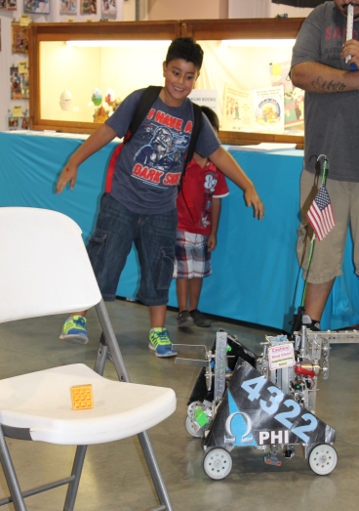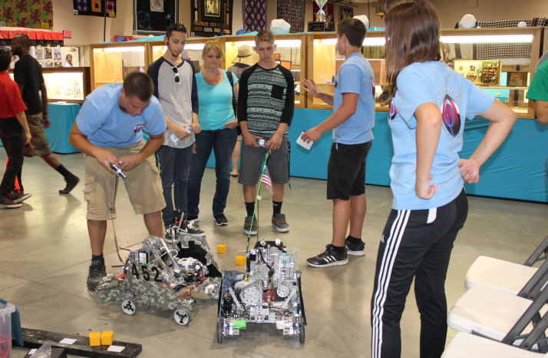
When Susan came back to check on us she said that there was a larger space in another part of the building that had just been cleared up for us. We then packed up our equipment and moved to the new location to continue demonstrating our robots. We also got to show some kids the internal workings of our robots.
